**Amazon Sales Analysis**

Submitted to

**International Institute of Professional Studies**

**Devi Ahilya Vishwavidyalaya**

**Indore.**

**2024**

By

**RIYA PATEL**

**(IC-2K19-70)**

**In partial fulfilment of the requirements for the Award of Degree in**

**Master of Computer Application.**

Under Supervision of

**Dr. Kirti Mathur Paras Grover**

**IIPS, Indore Unified Mentor**

**Certificate from the company**



**Certificate of completion of project from the company**



**DECLARATION**

I hereby declare that the project entitled **“Amazon Sales Analysis”** which is submitted by me for the partial fulfilment of the requirement for the award of Master of Computer Applications (5 Years) Semester X to International Institute of Professional Studies, Devi Ahilya Vishwavidyalaya, Indore comprises of my own work and has not been submitted any where else and due acknowledgement has been made in text to all other material used.

Signature of Student :

Date :

Place :

**DISSERTATION APPROVAL SHEET**

The dissertation entitled **“Amazon Sales Analysis”** being submitted by **Riya Patel (IC-2K19-70)** in partial fulfilment of the requirement for the award of Master of Computer Applications (5 Years) Semester X to International Institute of Professional Studies, Devi Ahilya Vishwavidyalaya, Indore is satisfactory and approved.

**Internal Examiner External Examiner**

**________________** ___________________

**Acknowledgement**

I am deeply indebted to my project guide, **Dr. Kirti Mathur**, for her invaluable guidance throughout the development of this project. I express my sincere gratitude to our Mentor **Mr. Rajesh Verma**, our Program In charge, **Mr. Jugendra Dongre**, as well as to **Dr. K. Tripathi**, Director of IIPS DAVV Indore, for their continuous support and encouragement, as well as their prompt assistance in monitoring the progress of the project. I am grateful for their valuable suggestions, which significantly contributed to making this project more efficient and user-friendly.

Additionally, my thanks and appreciation extend to my colleagues who collaborated in the development of this project, as well as to all those who have supported and assisted me along the way.

Riya Patel

IC-2K19-70

**Abstract**

The **"Amazon Sales Analysis Project"** aims to explore and analyse sales data from Amazon across different regions, item types, sales channels, and other relevant attributes. The dataset provides detailed information such as order dates, units sold, unit prices, total revenue, total cost, and total profit for various transactions.

The project encompasses several key steps, including data cleaning, visualization, identification of key metrics, exploration of relationships between attributes, and derivation of actionable insights.

Through comprehensive data cleaning and standardization processes, inconsistencies and missing values are addressed to ensure the reliability and accuracy of the analysis. Visualization techniques such as line charts, bar charts, and scatter plots are utilized to visualize sales trends, distribution patterns, and relationships between variables.

Key metrics such as total revenue, total cost, average unit price, and profit margin are calculated to provide insights into sales performance and profitability. The analysis also explores the impact of factors such as sales channels, item types, and order priorities on sales and profit.

By conducting a thorough analysis of the Amazon sales data, this project aims to uncover valuable insights and trends that can inform strategic decision-making and optimize sales strategies. The project concludes with actionable recommendations based on the findings, as well as suggestions for future research and analysis.

**TABLE OF CONTENTS**

**S.No. CONTENTS PAGE**

CERTIFICATE OF ALLOCATION Ⅰ

CERTIFICATE OF INTERSHIP COMPLETION Ⅱ

DECLARATION Ⅲ

DISSERTATION APPROVAL SHEET Ⅳ

ACKNOWLEDGEMENT Ⅴ

ABSTRACT Ⅵ

1. INTRODUCTION 1
2. INTRODUCTION 2
3. BACKGROUND
4. PROBLEM STATEMENT
5. OBJECTIVE
6. ARCHITECTURE 3
7. PROBLEM EVOLUTION 4
8. DATA GATHERING
9. DATA PREPROCESSING
10. DATA ANALYSIS
11. DATA VISUALISATION
12. SOFTWARE AND HARDWARE REQUIREMENT 5
    1. TOOLS USED (SOFTWARE) 6
    2. HARDWARE REQUIREMENT
13. KPIS AND CHARTS 7

4.1 KPIS 8

4.2 CHARTS

1. OUTPUT 9-17
2. CODING 18-22
3. CONCLUSION 23-24
4. REFERENCES 25-26

**LIST OF FIGURES**

|  |  |  |
| --- | --- | --- |
| **S. NO.** | **Name** | **Page NO.** |
| **1** | **Architecture of Business Intelligence** | **4** |
| **2** | **Main Dashboard** | **10** |
| **3** | **Year and Item wise Sales Trend** | **11** |
| **4** | **Yearly Total Cost, Profit, Revenue** | **12** |
| **5** | **Country and Regional Distribution** | **13** |
| **6** | **Item wise Profit** | **14** |
| **7** | **Region wise Profit** | **15** |
| **8** | **Year wise Profit** | **16** |
| **9** | **Sales Channel wise Profit** | **17** |
| **10** | **Import Libraries** | **19** |
| **11** | **Import Data** | **19** |
| **12** | **Data Columns** | **19** |
| **13** | **Data Info** | **20** |
| **14** | **Data Frame** | **20** |
| **15** | **Data** | **21** |
| **16** | **To check Null value** | **21** |
| **17** | **Total Profit** | **22** |
| **18** | **Total Revenue** | **22** |

**Chapter 1**

**Introduction**

**1.Introduction**

1.1 Introduction

Companies must handle sales well to thrive in the current dynamic business environment.

Platforms such as Amazon have transformed how enterprises sell their products, thereby presenting new opportunities and challenges at the same time. This paper seeks to examine data on sales made through Amazon so as to identify some of the insights that can be relied upon by firms in making better decisions for growth.

1.2 Background

In 1994, Amazon was established as an online bookstore and has since grown into one of the largest e-commerce platforms worldwide. Its success can be attributed to its customer-centric approach coupled with innovative technology which has not only revolutionized shopping but also changed how businesses operate in this industry.

1.3 Problem Statement

Sales management has gained importance to meet increasing competition and the need for improved methods of distribution to reduce cost and to increase profits. Sales management today is the most important function in a commercial and business enterprise.

1.4 Objective

The key aim behind this study is to elucidate trends or patterns discernible from Amazon’s sales record. Our methods will involve using techniques of analysing data so that we may establish what metrics matter most; determine those factors that impact on sales volumes most significantly as well identify any other useful findings capable of enhancing company’s strategies for boosting sales.

**Chapter 2**

**Architecture**

**2. Architecture**

Fig. 1 Architecture of Business Intelligence

1. Problem Evolution:

• Define business objectives and KPIs.

• Formulate hypotheses or questions for investigation.

1. Data Gathering:

• Identify and collect relevant data from various sources.

• Integrate data into a unified dataset.

1. Data Preprocessing:

• Clean data by handling missing values, outliers, and duplicates.

• Transform and engineer features to prepare for analysis.

1. Data Analysis:

• Conduct exploratory data analysis (EDA) to understand patterns.

• Apply statistical techniques and machine learning for insights.

2.5 Data Visualisation:

• Select appropriate visualization techniques.

• Create visualizations to communicate insights effectively.

**Chapter 3**

**Software and Hardware Requirement**

**3. Software and Hardware Requirement**

3.1 Tools Used (Software)



Business Intelligence tool Power BI is used to build the whole framework.

**Microsoft Power BI** is an interactive Data Visualisation software product developed by Microsoft with a primary focus on Business Intelligence It is part of the Microsoft Power Platform. Power BI is a collection of software services, apps, and connectors that work together to turn various sources of data into static and interactive data visualizations.

3.2 Hardware Requirement

Processor: Quad- core or higher with clock speed >= 2.0 GHz

RAM: >= 8 Gb

Graphics: Dedicated graphics Card for improved rendering

Storage: SSD for faster data access

Operating System: Window 10

Network Connection: Stable internet Connection required for accessing online data sources, sharing reports

**Chapter 4**

**KPIs and Charts**

**4. KPIs and Charts**

KPIs are like scorecards that show how well a business is doing, while charts are like pictures that help us see and understand the scorecard better. They work together to help businesses make smart decisions and keep track of their progress.

4.1 KPIs (Key Performance Indicators)

Key indicator displaying a summary of Amazon sales data.

1. Total Profit

2. Total Revenue

3. Total Cost

4. Total Unit Sold

4.2 Charts

Charts displaying an understanding of Amazon sales data.

1. Item wise Profit (Tree Map)

2. Resign wise Profit (Pie Chart)

3. Year wise Profit (Bar Chart)

4. Sales Channel wise Profit (Bar Chart)

5. Country wise Profit (Map)

6. Year wise Sales Trend (Line Chart)

7. Item wise Sales Trend (Funnel)

8. Year wise Total Cost, Total Profit and Total Revenue (Bar Chart)

9. Country wise Order Priority (Map)

10. Country wise Total Profit (Map)

11. Country wise Sales Channel (Map)

12. Region wise Distribution (Map)

**Chapter 5**

**Output**

**5. Output**

The output consists of visual Dashboards and reports summarizing Amazon sales Trends and insights, helping decision-makers to understand performance and make informed choices.

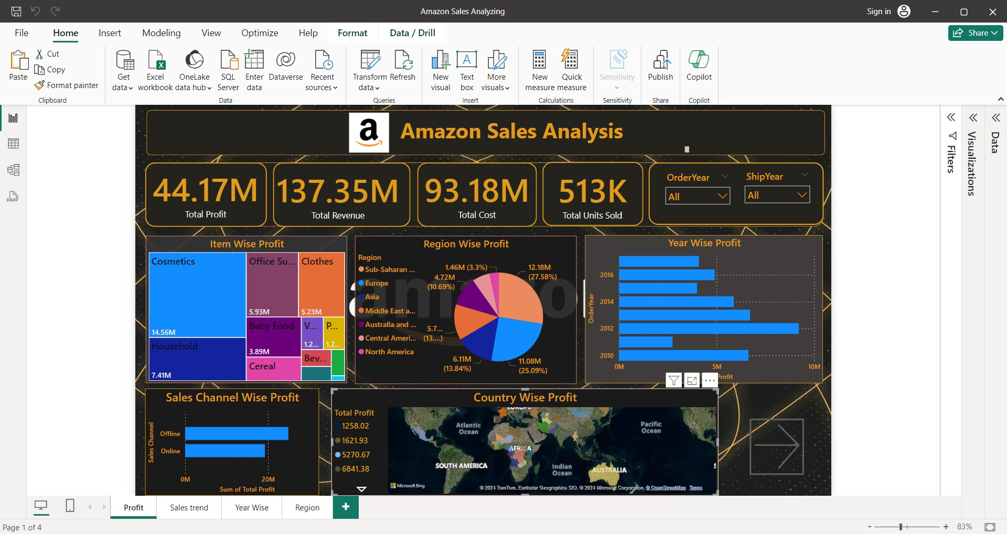

Fig. 2 Main Dashboard

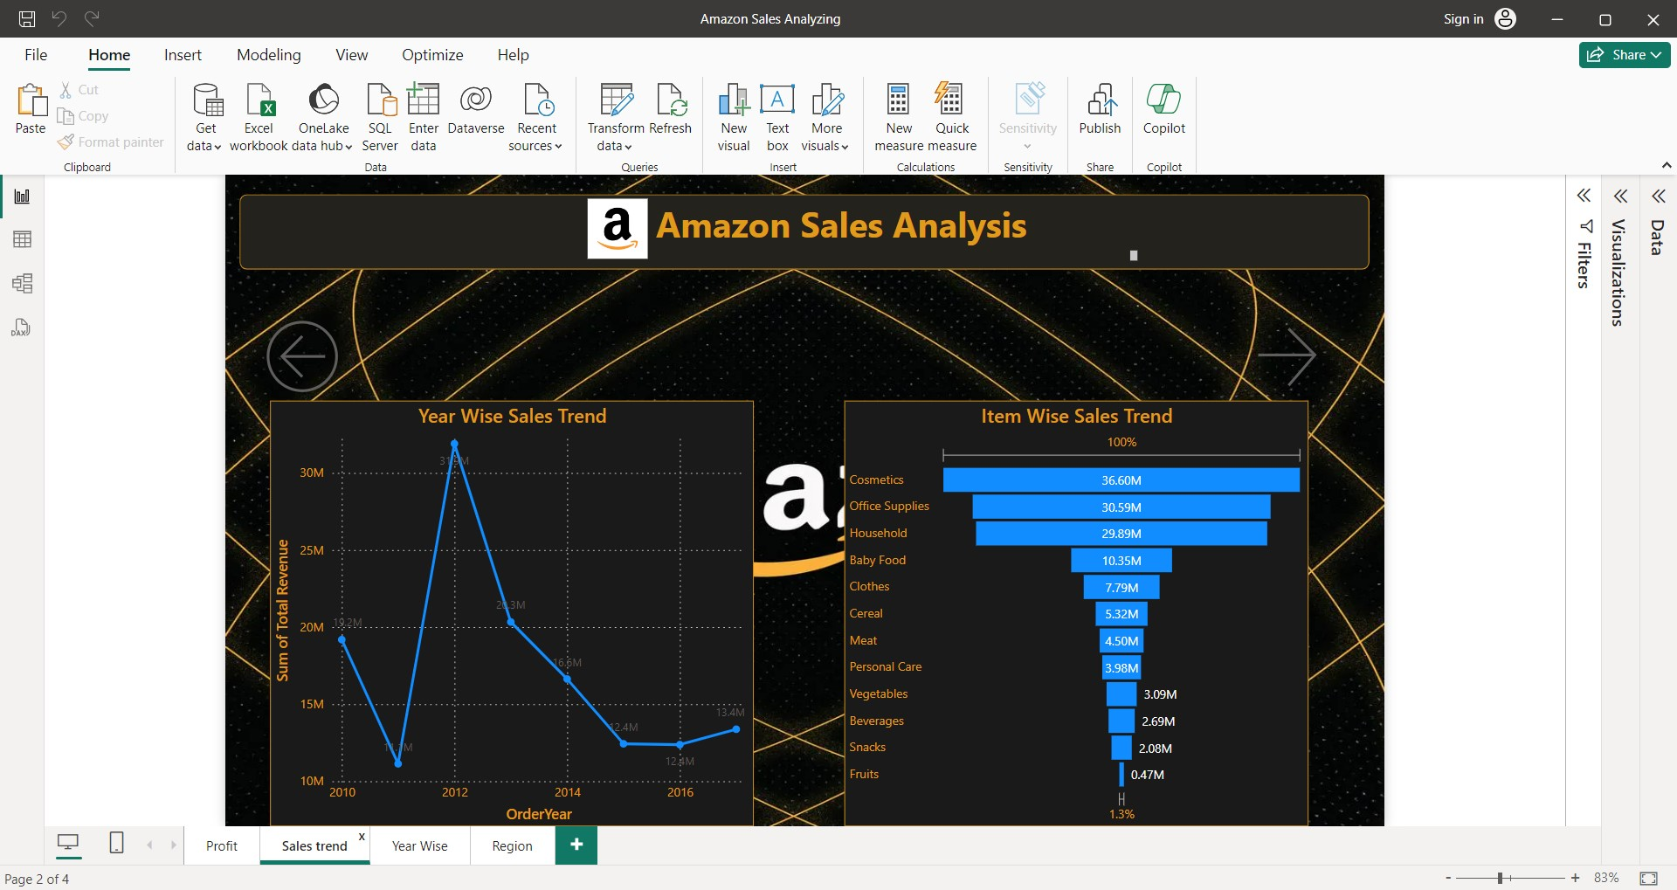

Fig. 3 Year wise and Item wise Sales Trends

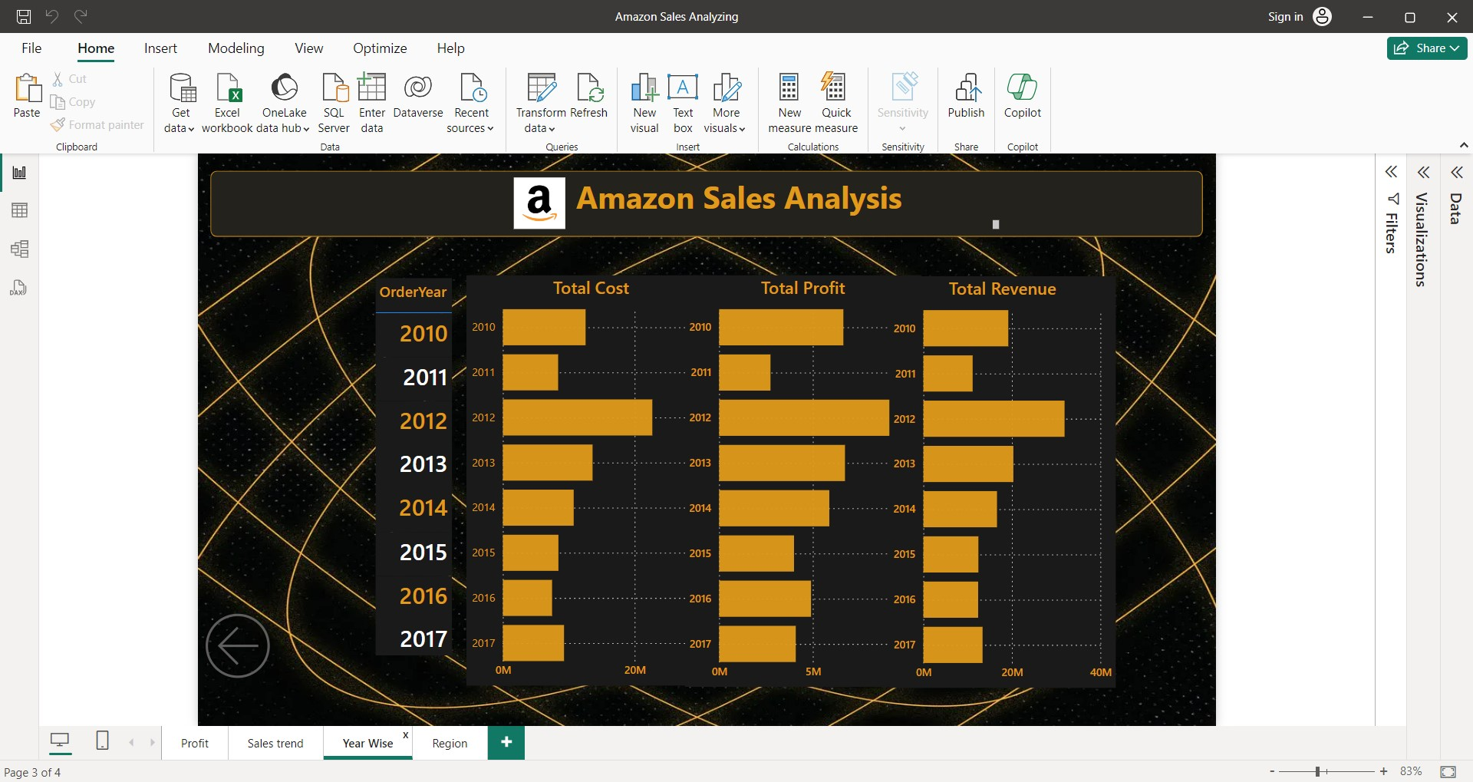

Fig. 4 Yearly Total Cost, Profit, Revenue

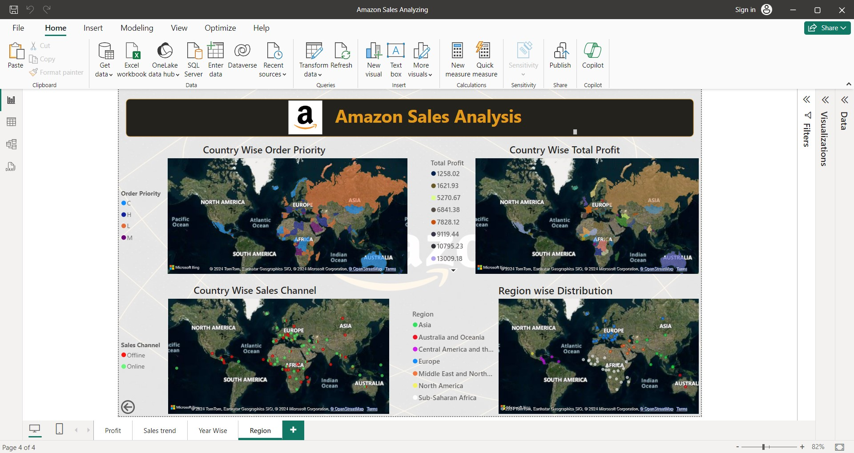

Fig. 5 Country wise and Regional Distribution

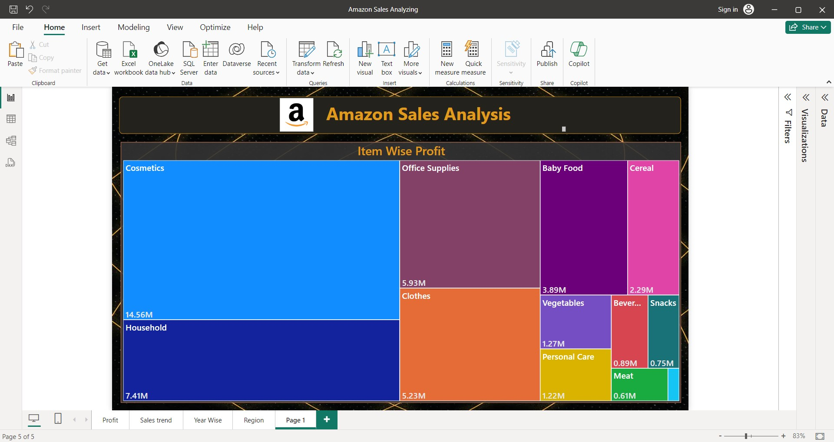

Fig. 6 Item wise Profit

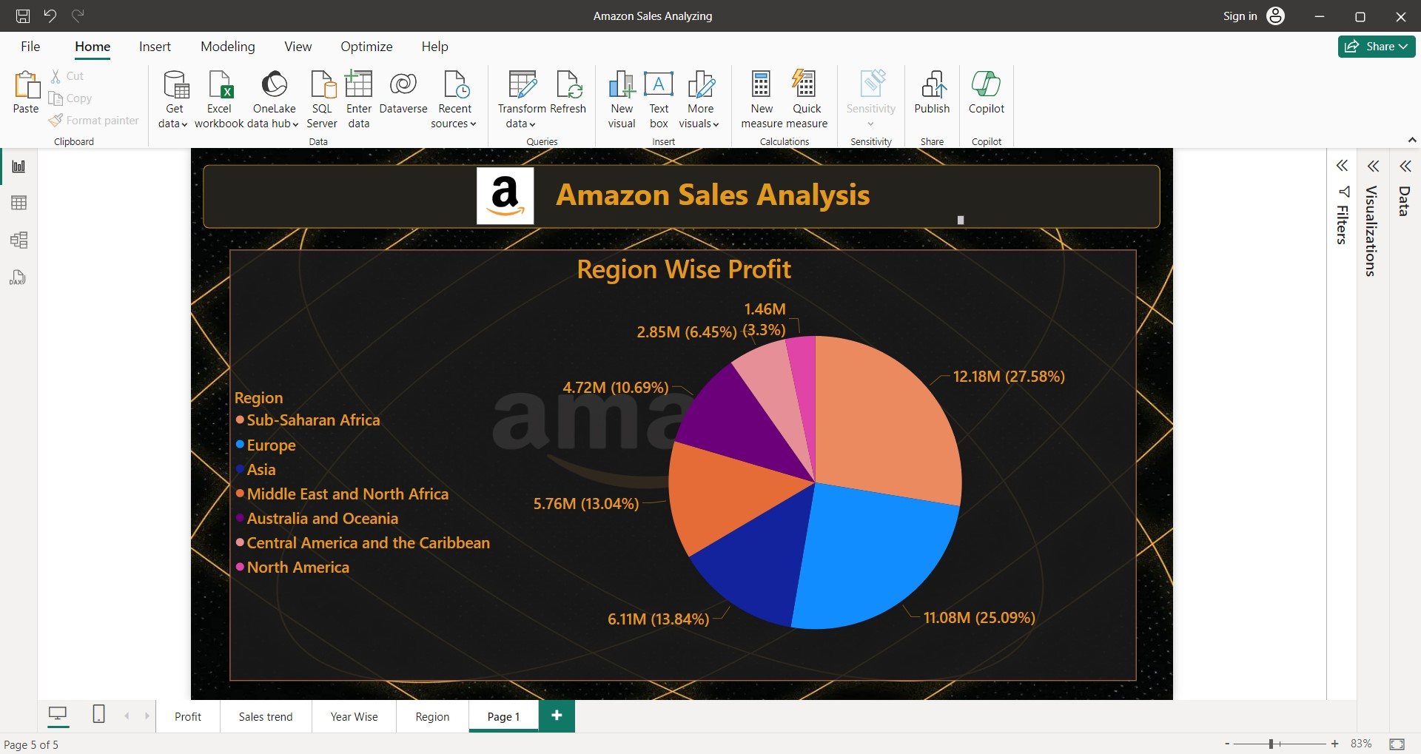

Fig. 7 Region Wise Profit

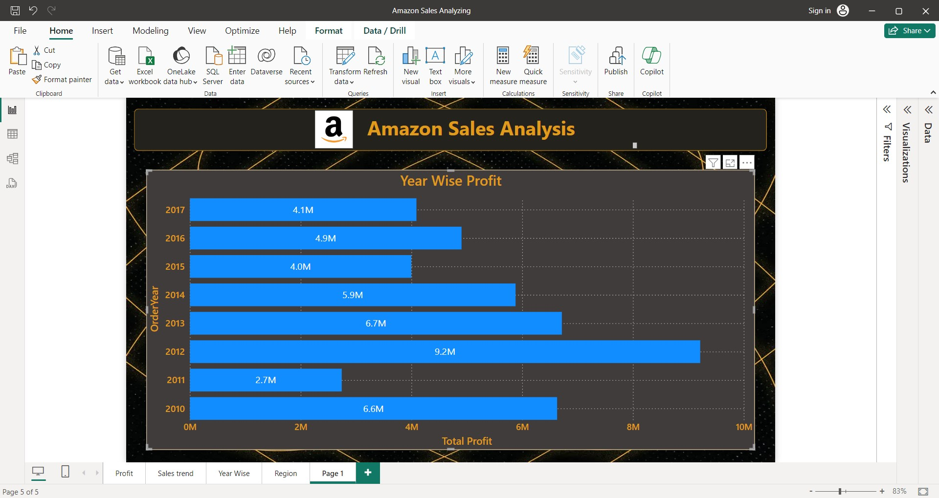

Fig. 8 Year wise Profit

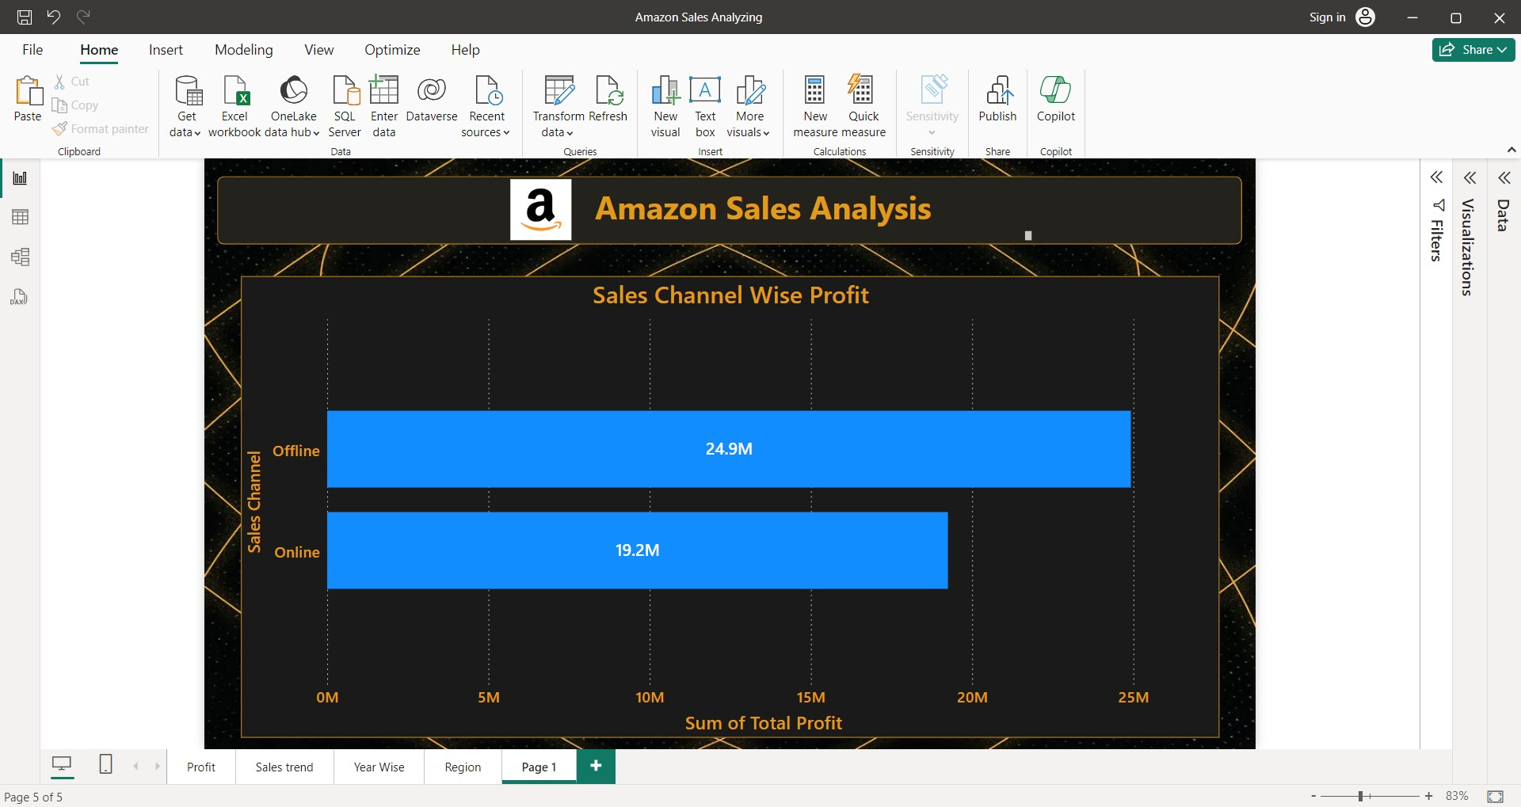

Fig. 9 Sales Channel wise Profit

**Chapter 6**

**Coding**

**6. Coding**

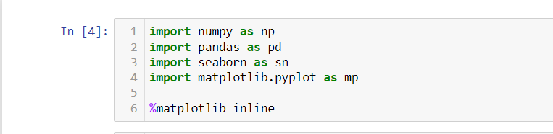

Fig. 10 Import Libraries



Fig. 11 Import Data

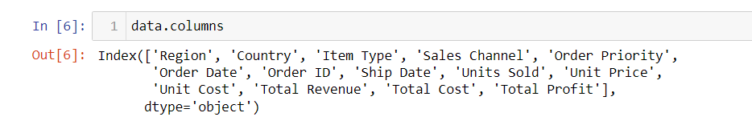

Fig. 12 Data Columns

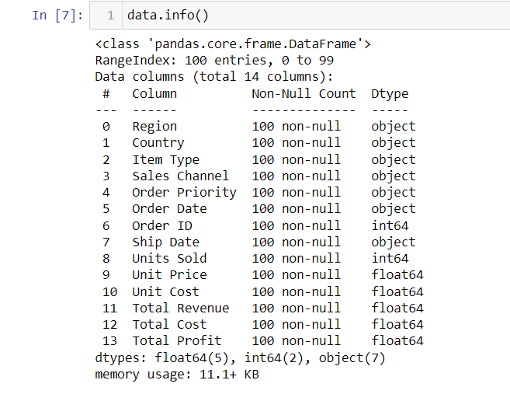

Fig. 13 Data Info

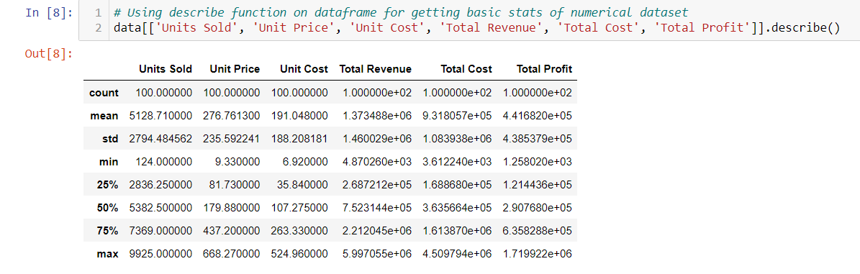

Fig. 14 Data Frame

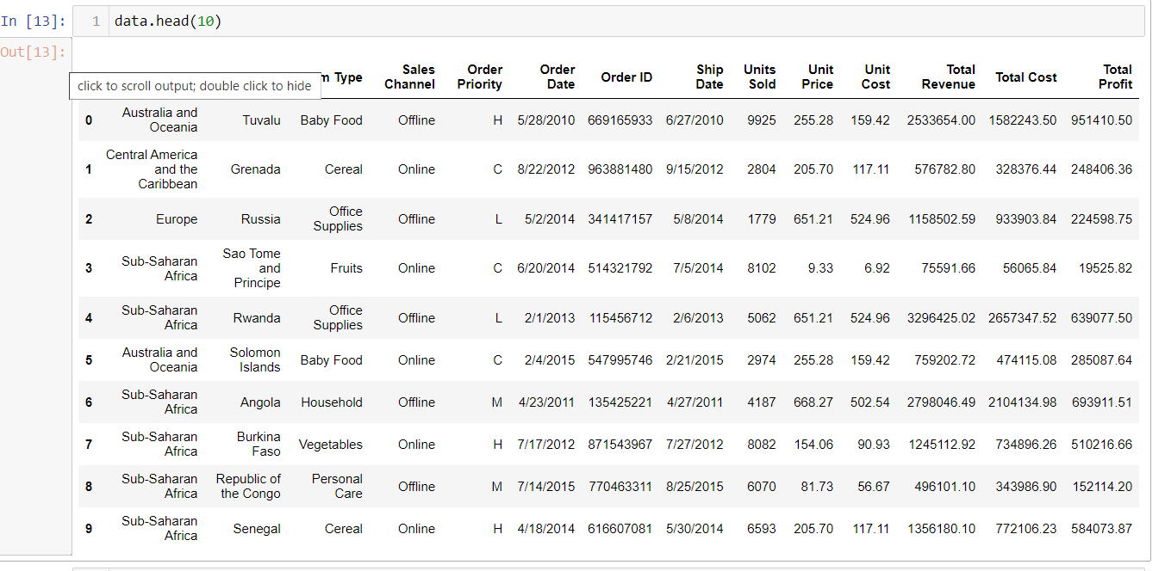

Fig. 15 Data

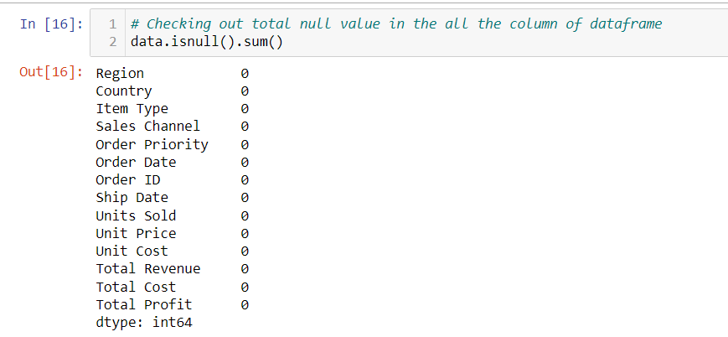

Fig. 16 To check Null Value

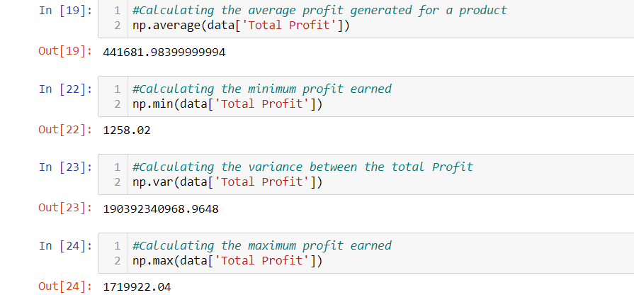

Fig. 17 Total Profit

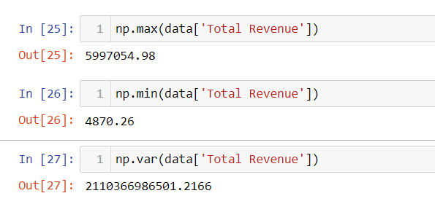

Fig. 18 Total Revenue

**Chapter 7**

**Conclusion**

**7. Conclusion**

1. 2012 has the highest profit of 9.21M.

2. 2011 has the lowest profit of 2.74M.

3. Cosmetics are the highest profit item at 14.56M.

4. Fruits are the lowest profit item at 1.20M.

5. Sub-Saharan Africa has the highest profit of 12.18M.

6. North-America has the lowest profit of 1.46M.

7. Offline sales Channel has the profit of 24.92M.

8. Online sales Channel has the profit of 19.25M.

**Chapter 8**

**Reference**

**8. Reference**

Data Set: <https://drive.google.com/file/d/10sofXyF6NjwN6ngLyFfiPI-CUDpeqaN_/view>

Other: <https://en.wikipedia.org/wiki/Microsoft_Power_BI>

<https://github.com/sivamsinghsh/Amazon-Sales-Data-Analysis>